Chapter 5, Problem 38

Using Fig. 5.75, design a problem to help other students better understand summing amplifiers.
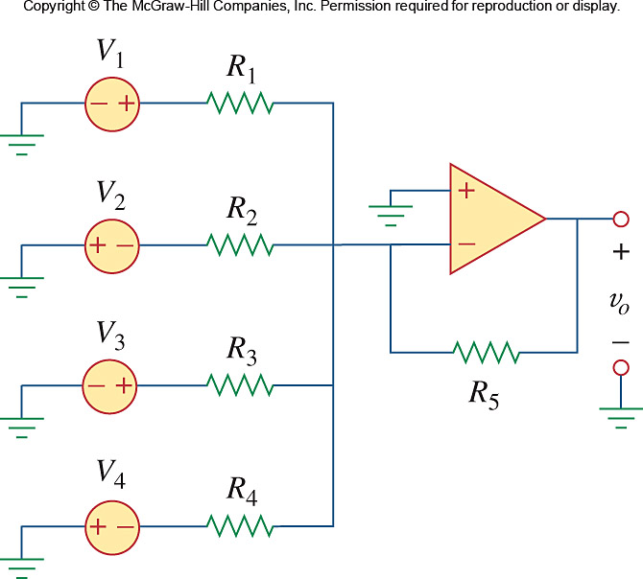

Figure 5.75
For Prob. 5.38.

